A total of 130 contributors gifted their time and expertise to the planning, set-up, filming and development of PreVET . Of this:

- Coordination Assistance – 57
- Interview participants - 73

Victoria Daly Shire Council  Coordination Assistance  Trevor Troy  Interviews  Reg King  Wesley Campbell  Warick Campbell | Power & Water  Coordination Assistance  John Harris  Interviews  Anthony Kennedy | Gold Medal Services  Coordination Assistance  Jackie McLean  Interviews  David Laughton
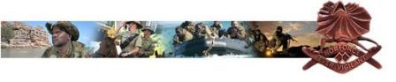  North West Mobile Force (NORFORCE)  Coordination Assistance  Chris Delaney  Paul O’Donnell  Peter Young  Jone Lotu  Glen Kuschert  Interviews  Alistair Evans  Jeffrey Norman  Mel Langdon  Leonard Lami Lami  Ida Walanga | Roper Gulf Shire Council  Coordination Assistance  Vicki New  Interviews  Aged care | AA Electrical  Coordination Assistance  David Pal  Interviews  Tony Walaluma
Wugularr Age Care Centre  Coordination Assistance  Roper Gulf Shire  Interviews  June Jolly  Caroline Wurrben | Frontier Services  Coordination Assistance  Judy Ratajec  Charmain Collins  Interviews  Kay Wilson  Lynnete Talbot | West Arnhem Shire  Coordination Assistance  Troy Croton - Jabiru  Kupa Teao - Gunbalanya  Clem Beard  Interviews  Derek Carter  Jamie Yibarbuk  Don McGregor  Ricky Gurrawiwi
Richards Crane Hire  Coordination Assistance  Chez Sheldon-Williams  Interviews  Jason Kent | 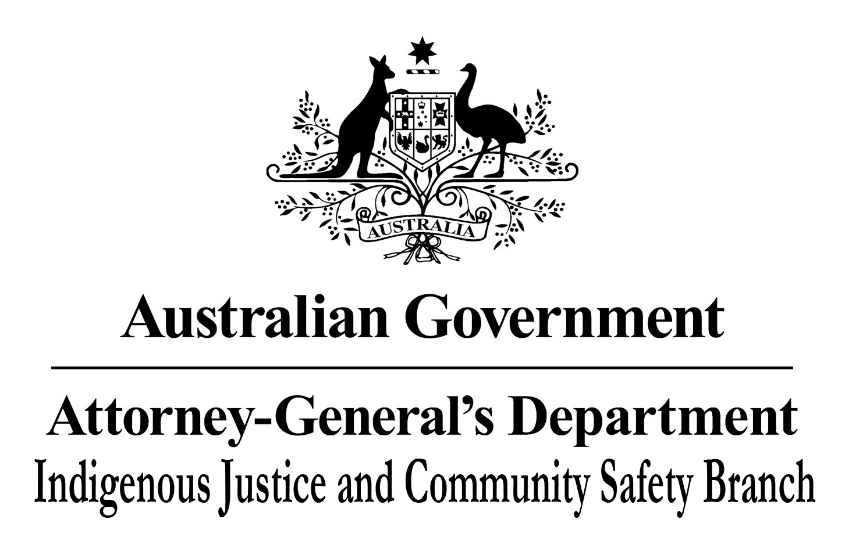  Attorney-General’s Department – Indigenous Justice and Community Safety Branch  Coordination Assistance  Judy Roediger  Interviews  Community Night Patrol | Major Industries Training Advisory Council  Coordination Assistance  Archie Wright  Deb Carr  Interviews  Building Construction
Energy Resources of Australia - Ranger Mine  Coordination Assistance  Shannon McRae  Interviews  Richard Linder  Coby Wright-Cronin | Yellow Water Cruises  Coordination Assistance  Louise Webster  Interviews  Sheldon Liddy | Nitmiluk Tours  Coordination Assistance  Tessa & Clive Pollock  Interviews  Robbie Braun  Terrance Runyu  Dion Pollard  Cory Alum  Tony Walla  Henry Braun
Kakadu National Park  Coordination Assistance  Penny Scarpellino  Interviews  Shari Aluni  Savana Eccles  Tour Guides  Patrick Green | Gagudju Crocodile Holiday Inn  Coordination Assistance  -  Interviews  Tour Guides  Teresa Nagawalli | 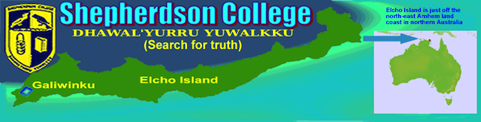  Shepherdson College  Coordination Assistance  Adam Bester  Interviews  Brendan Burarrwanga  Caroline Burarrwanga
Arnhem Land Progress Aboriginal Corporation - ALPA  Coordination Assistance  Chris Hayward  Care Brown  Michael Nemarich  Interviews  Jeffrey Danydjati  Elaine Dhapanga  Sonya Bidingal  James Gengi  Maree (Molly) Bryan  Sylvia Mawularri | Xstrata Zinc - McArthur Mine  Coordination Assistance  Chrissy Joll  Interviews  Clayton Anderson  Julie Crawford  Michayla Holt | Transport, engineering & Automotive Industries Training Advisory Council - TEATAC  Coordination Assistance  Terry Lawler  Interviews  Transport & Logistics
Traditional Credit Union - TCU  Coordination Assistance  Simon Day  Anne Shew  Chris Pointon  Interviews  Raelene Gaykamangu  Roslyn Wunungmurra | Thamarrurr Development Corporation  Coordination Assistance  -  Interviews  Rangers | 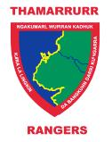  Thamarrurr Rangers  Coordination Assistance  Michael Schultz  Interviews  Maureen Simon  Angus Melpi
Gumurr Marthakal Rangers and  Marthakal Badurru Workshop  Galiwin’ku  Coordination Assistance  Damien Clayton  David Collins  Interviews  Ralph Marrayumba Garrawarra  Jonathan Gulurrwuyz Garawirrtja  Justin Garawimtja | 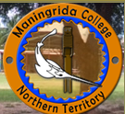  Maningrida College  Coordination Assistance  Clinton Wearing  Anthony Gnomes  Interviews  Simon Pascoe  Indra Prudence  Shirley Turner | Borroloola School  Coordination Assistance  Graeme Matthews  Interviews  Noela Anderson
Gunbalanya Creche  Coordination Assistance  Kate Danvers  Interviews  Erica Balmana | NaWulgWulg Family Care Service  Coordination Assistance  Jade Brown  Interviews  Barbara Berto  Jade Brown  Haley Peckham | Integrated Family Services  Coordination Assistance  Kate Race  Interviews  Childcare  Education Support
Aboriginal Community Police – Remote Policing  Coordination Assistance  Wendy Morrison  Commander Kym Davies  Superintendant Craig Barrett  A/Superintendant Michael Hebb  Interviews  Daniel Sandy  Bettina Danganbarr  Gwen Brown | Community Night Patrol  Coordination Assistance  Brian Corby  John Chisholm  Interviews  Cedric Egan  Kyle Dunn  Warren Kunoth  Elizabeth Katkarinja | Building the Remote Early Childhood Workforce  Coordination Assistance  Elizabeth Banney  Interviews  Childcare
Human Services Training Advisory Council - HSTAC  Coordination Assistance  Judith McKay  Interviews  Community Night Patrol | Laynhapuy Homelands Aboriginal Corporation - Yirralka Rangers  Coordination Assistance  David Preece  Fiona Shaw  Interviews  Gurrundul Marika | Central Australian Aboriginal Congress  Coordination Assistance  Des Rogers  Interviews  Business Management
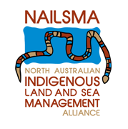  North Australian Indigenous Land and Sea Management Alliance Ltd (NAILSMA)  Coordination Assistance  Erica McCreedy  Interviews  Business Management | Kungka’s Can Cook  Coordination Assistance  -  Interviews  Rayleen Brown | Mistake Creek Cattle Station  Coordination Assistance  -  Interviews  Derek Yarrak  Fenton Karyuaka  Jo-anne Craig  Steve Craig

